C-PASS 2023, One-Page Summary Template

(Title should be centred 14 pt Times bold type)

Name Surname¹, Name Surname¹, Name Surname² [10-point type, centred, bolded]
1. Polytechnic University of Bari, Via E. Orabona, 4, 70125, Bari – Italy address (8-point type, centred, italicized)
2. Università degli Studi di Bari Aldo Moro - Piazza Umberto I - 70121 Bari (Italy) (8-point type, centred, italicized)

Short abstract: The appearance of this document reflects the requirements of the style guide and formatting of main text. The use of this style guide is critical to provide a consistent appearance. This short abstract should be up to 50 words long (appearing on the C-PASS website as summary of the program).

This is the template document format for the one-page extended abstract for submissions to C-PASS 2023 for technical review. Although this document is provided in Microsoft Word format, the paper to be uploaded must be in PDF format. Paper size should be A4 format (210 mm x 297 mm). Margins should be set for a 2.5 cm top, bottom, left, and right. For text fonts: use only 10pt Times (roman, bold or italic), and Symbol. Include all equations, drawings, figures and references within the one-page limit. Avoid asterisks, acknowledgements, job descriptions or footnotes. Do not add page numbers.
Lorem ipsum dolor sit amet. Et vero accusantium eos dolorum voluptates et tempore eligendi et temporibus officia. Est quibusdam nisi qui veniam autem aut nesciunt dolores aut tenetur repellat qui dignissimos cupiditate! Ut dolorem ipsum eos consequatur alias id consequatur aliquam ea quia deserunt id nihil earum. Non consequatur delectus est delectus culpa et dolorem minima aut veniam placeat cum quae recusandae ad soluta vero! Sit cupiditate ipsam et voluptas iusto ut ratione porro. Vel omnis dicta sit nihil voluptatum vel perferendis nihil et voluptas quod et adipisci galisum et commodi error. Est nisi perspiciatis ea veniam veritatis aut dignissimos earum sit dolore maxime a dignissimos laudantium qui vero harum non totam facilis. Non facilis ratione sit quidem iusto et rerum pariatur ut expedita distinctio?

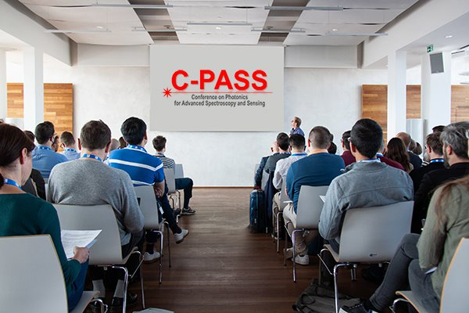
Fig. 1 Figure caption.

References should appear at the end of the article in the order in which they are referenced in the body of the paper. The font should be 8 point, and the references should be aligned left. A suggested format for references is given below. Within the main text, references should be designated by a number in brackets [1], and they should precede a comma or period. Two references cited at once should be included together [1,2], separated by a comma, while three or more consecutive references should be indicated by the bounding numbers and a dash [1–3].

References
[1] J. Itatani, D. Zeidler, J. Levesque, D. M. Villeneuve, and P. B. Corkum, "Controlling High Harmonic Generation with Molecular Wave Packets," Phys. Rev. Lett. 94, 123902 (2005). For journal articles, authors are listed first, followed by the article’s full title in quotes, the journal’s title abbreviation, the volume number in bold, page number, and the year in parentheses.
[2] David F. Edwards, Handbook of optical constants of solids, E.D. Palik, ed., Academic, Orlando, Fla. (1985). For citation of a book as a whole: authors, followed by title in italics, and publisher, city, and year in parenthesis.

